FUNDAMENTALS OF DATA SCIENCE

LAB PROGRAMS

DSA 0412-Fundamentals Of Data Science for Data Analytics

M S GOWRISH SHANKAR REDDY
192424270

09/01/2026

11. Scenario : You are a data scientist working for a company that sells products online. You have been tasked with creating a simple plot to show the sales of a product over time.
Question:
1. Write code to create a simple line plot in Python using Matplotlib to predict sales happened in a month?
2. Write code to create a scatter plot in Python using Matplotlib to predict sales happened in a month?
3. Develop a Python program to create a bar plot of the monthly sales data.
Code:
import pandas as pd
import matplotlib.pyplot as plt
data = pd.read_csv("monthly_sales_prediction.csv"
months = data["Month"]
sales = data["Sales"]
plt.figure()
plt.plot(months, sales)
plt.xlabel("Month")
plt.ylabel("Sales")
plt.title("Monthly Sales Prediction - Line Plot")
plt.show()
plt.figure()
plt.scatter(months, sales)
plt.xlabel("Month")
plt.ylabel("Sales")
plt.title("Monthly Sales Prediction - Scatter Plot")
plt.show()
plt.figure()
plt.bar(months, sales)
plt.xlabel("Month")
plt.ylabel("Sales")
plt.title("Monthly Sales Data - Bar Plot")
plt.show()
output:
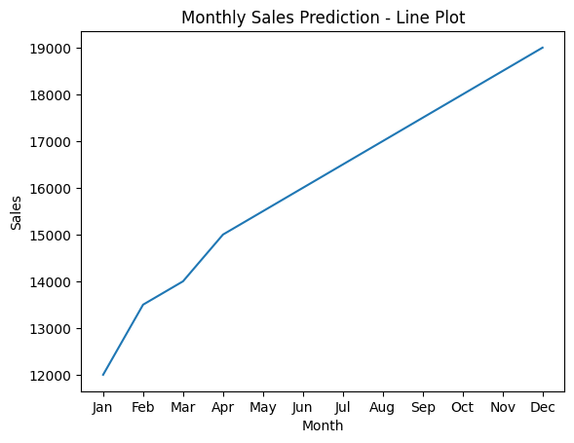
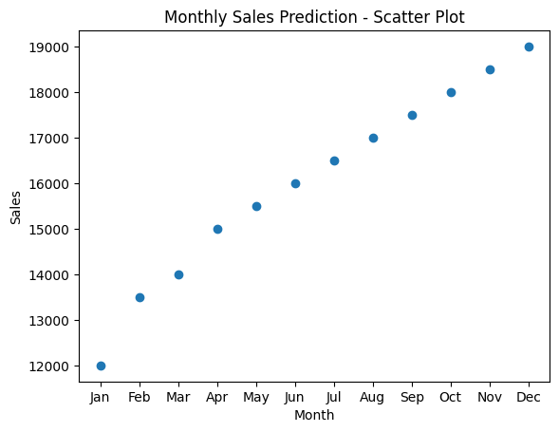
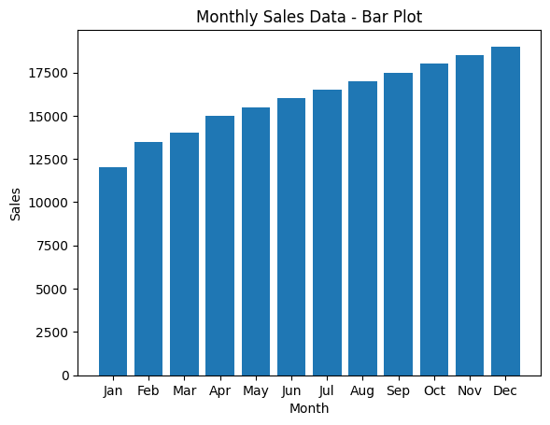
12. Scenario: You are working on a data analysis project that involves analyzing the monthly temperature and rainfall data for a city. You have a dataset containing the monthly temperature and rainfall values for each month of a year. Your task is to develop a Python program that generates line plots and scatter plots to visualize the temperature and rainfall data.
Question:
1. Develop a Python program to create a line plot of the monthly temperature data.
2: Develop a Python program to create a scatter plot of the monthly rainfall data.
Code:
import pandas as pd
import matplotlib.pyplot as plt

data = pd.read_csv("monthly_weather_data.csv")

year_data = data[data["Year"] == 2022]

months = year_data["Month"]
temperature = year_data["Temperature_C"]
rainfall = year_data["Rainfall_mm"]

plt.figure()
plt.plot(months, temperature)
plt.xlabel("Month")
plt.ylabel("Temperature (°C)")
plt.title("Monthly Temperature Data (2022)")
plt.show()

plt.figure()
plt.scatter(months, rainfall)
plt.xlabel("Month")
plt.ylabel("Rainfall (mm)")
plt.title("Monthly Rainfall Data (2022)")
plt.show()
output:
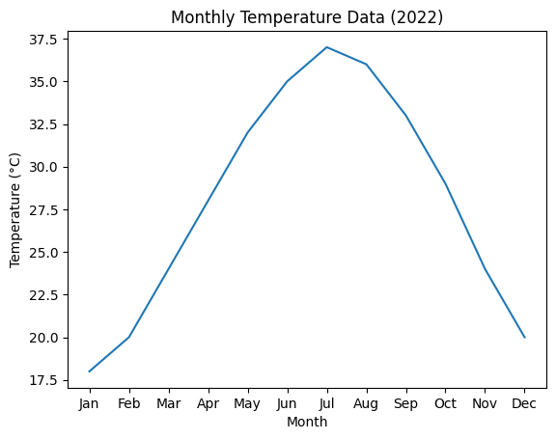
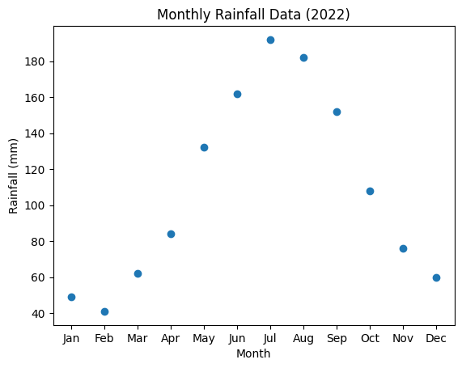
13. Scenario: You are working on a text analysis project and need to determine the frequency distribution of words in a given text document. You have a text document named "sample_text.txt" containing a paragraph of text. Your task is to develop a Python program that reads the text document, processes the text, and generates a frequency distribution of the words.
Question: How would you develop a Python program to calculate the frequency distribution of words in a text document?
Code:
import pandas as pd
from collections import Counter
import string

df = pd.read_csv("sample_text.csv")

text = " ".join(df["text"]).lower()

text = text.translate(str.maketrans("", "", string.punctuation))

words = text.split()

word_frequency = Counter(words)

print("Word Frequency Distribution:")
for word, count in word_frequency.items():
print(word, ":", count)

Output:
Word Frequency Distribution:
data : 18
science : 5
is : 7
an : 3
interdisciplinary : 1
field : 1
that : 1
uses : 1
scientific : 1
methods : 1
processes : 1
algorithms : 2
and : 14
systems : 1
to : 6
extract : 1
knowledge : 1
from : 2
machine : 5
learning : 5
a : 3
core : 1
part : 1
of : 4
enables : 1
computers : 1
learn : 1
python : 3
one : 1
the : 1
most : 1
popular : 1
programming : 1
languages : 1
for : 4
analysis : 8
involves : 1
cleaning : 1
processing : 2
visualizing : 1
gain : 1
useful : 1
insights : 2
big : 2
technologies : 1
help : 1
organizations : 1
store : 1
analyze : 2
large : 2
volumes : 1
text : 5
important : 2
application : 1
natural : 1
language : 1
used : 5
such : 2
as : 2
reviews : 1
social : 1
media : 1
posts : 1
word : 2
frequency : 2
basic : 1
technique : 1
in : 4
mining : 2
many : 1
companies : 2
use : 1
improve : 2
decision : 2
making : 2
business : 1
strategies : 1
are : 3
prediction : 1
classification : 1
clustering : 1
tasks : 1
provides : 1
libraries : 1
numpy : 1
pandas : 1
matplotlib : 1
can : 1
be : 1
structured : 1
or : 1
unstructured : 1
requires : 1
preprocessing : 1
before : 1
scientists : 1
often : 1
work : 1
with : 1
datasets : 1
discover : 1
patterns : 1
trends : 1
artificial : 1
intelligence : 1
closely : 1
related : 1
fields : 1
visualization : 1
helps : 3
present : 1
understandable : 1
way : 1
techniques : 1
widely : 2
sentiment : 1
customer : 1
feedback : 1
products : 1
services : 1
analytics : 1
supports : 1
real : 1
time : 1
automation : 1
distribution : 1
identify : 1
terms : 1
document : 1

14. Scenario: You are a data analyst working for a company that sells products online. You have been tasked with analyzing the sales data for the past month. The data is stored in a Pandas data frame.
Question: Develop a code in python to find the frequency distribution of the ages of the customers who have made a purchase in the past month.
Code:
import pandas as pd
sales_data = pd.read_csv("Sales_data.csv")
sales_data["Order_Date"] = pd.to_datetime(sales_data["Order_Date"])
latest_date = sales_data["Order_Date"].max()
past_month_data = sales_data[
sales_data["Order_Date"] >= latest_date - pd.DateOffset(months=1)
]
age_frequency = past_month_data["Age"].value_counts()
print("Frequency distribution of customer ages (past month):")
print(age_frequency)

output:
Frequency distribution of customer ages (past month):
Age
22 1
35 1
28 1
42 1
30 1
25 1
38 1
45 1
29 1
33 1
27 1
41 1
36 1
24 1
31 1
48 1
26 1
39 1
34 1
44 1
Name: count, dtype: int64
15. Scenario: You are a data analyst working for a social media platform. As part of your analysis,you have a dataset containing user interaction data, including the number of likes received by each post. Your task is to develop a Python program that calculates the frequency distribution of likes among the posts.
Question: Develop a Python program to calculate the frequency distribution of likes among the posts?
Code:
import pandas as pd

data = pd.read_csv("post_likes.csv")

likes_frequency = data["Likes"].value_counts()

print("Frequency distribution of likes among posts:")
print(likes_frequency)
output:
Frequency distribution of likes among posts:
Likes
25 4
40 4
60 3
80 3
100 3
120 2
140 1
Name: count, dtype: int64

